**Create Your first python App and Dockerise**



This page shows you how to do the following:

1. Create a Hello World app version 1 App.
2. Run it locally as service
3. Dockerise the application
4. Create python repo in Google container registry
5. Push python Version 1 image to GCR and Deploy the container image

**Step 1 : download the code**

apt install docker-buildx python3-pip -y

git clone https://github.com/anilbidari/python-kubernetes.git

**step 2 : change directory**

cd python-kubernetes/app

**step 3 : review main.py ( this is your hello world python application)**

vim main.py

change “Hello from python” to Hello I am version 1 and then save file

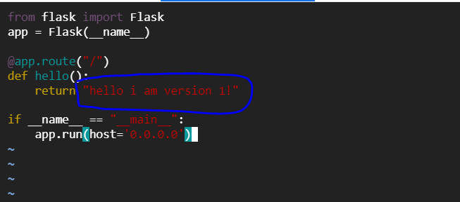

### **Step 4 : read the dockerfile**

cat Dockerfile

**Step5 : build docker image v1**

docker buildx build -t anilbidari/python:v1 .

**Step-6 Now we have to push the image. Run the below command.**

docker login

**Note: enter you docker id and password to login**

docker push anilbidari/python:v1

**Try – docker login if not able to push**

**Step-9: Ensure We can see that it is pushed.**

**Step-10: deploy v1 app as container**

docker run -d --name c1 -p 6001:80 anilbidari/python:v1

**step 11 : verify app1 is running**

curl http://localhost:6001

